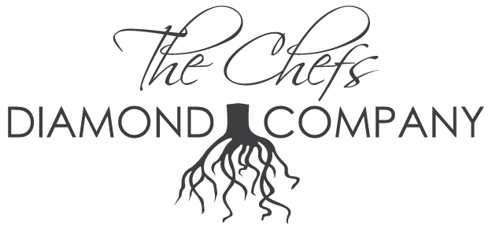

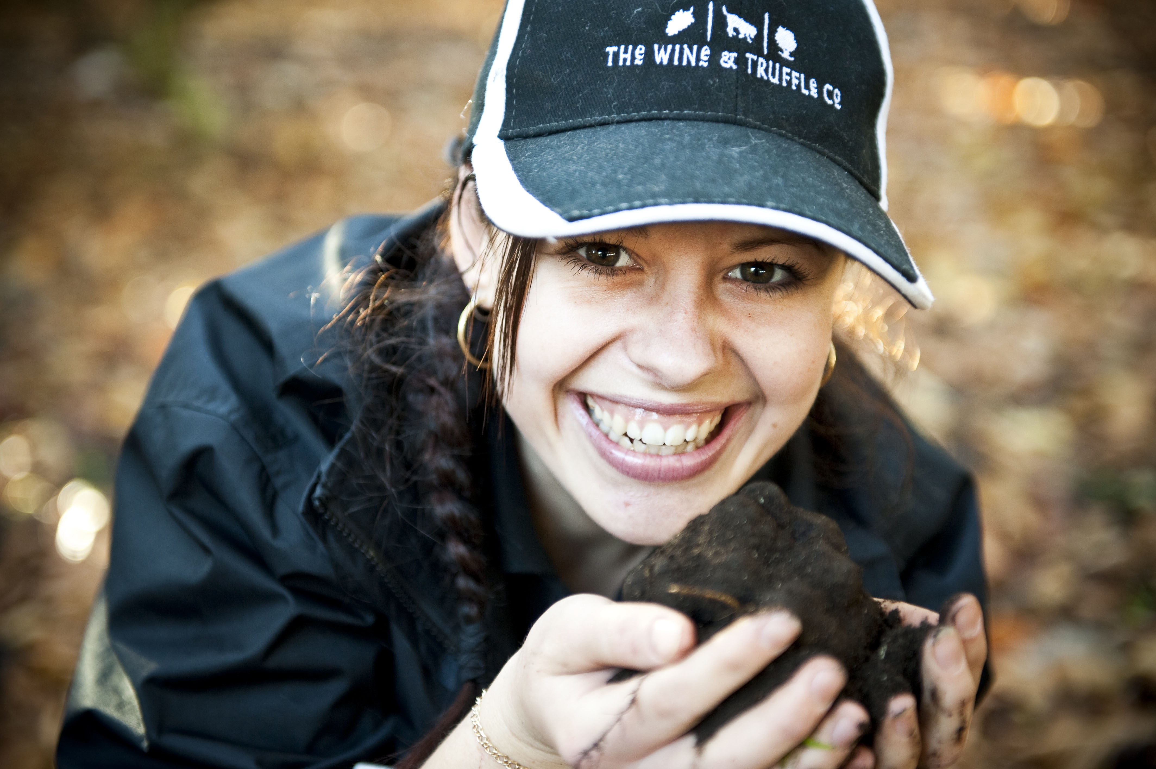

FOR IMMEDIATE RELEASE

FOR: The Chefs Diamond Company
Truffle Importers, Retail, Restaurant and Wholesale

www.thechefsdiamond.com

219-985-5926

CONTACT: King Truff
Frank Brunacci
219-798-5662
kingtruff@gmail.com

Chef Frank Brunacci leaves Trump Post to Bring Truffles to the Midwest

(CHICAGO; July 8th 2011) – Currently in their 2nd season distributing to the chefs around the country, The Chef’s Diamond Company founded by Lillian Brunacci alongside her Australian Husband and Chef Frank Brunacci have now launched their Online Retail store www.thechefsdiamond.com offering In season Fresh Truffles to the General Public, Private Chefs and Foodies alike… This is an important step in the creation of the common goal of a High End Retail / Restaurant in the Heart of Chicago…Slotted to Open Mid 2012, Truffles have been coming up from the ground from the Farm in Manjimup, Western Australia since the first week of June, The season will last until the 3rd week in September www.wineandtruffle.com ‘WTC’

“We have created a Partnership with the Wine and Truffle Company to go post season with a High End Retail store of mainly Australian and other products from around the world, WTC has developed a wide range of Truffle Products from oils, pastas, polenta and gift packs, Not to mention their own brand of wine, this in conjunction with sourcing some of the world’s unique ingredients like the wagyu beef, Iberico Pork, Caviars, world sourced Live shellfish, and a Fresh Pasta House and of course The Chef’s Diamond Truffles”

“We currently import Fresh Summer truffles from Europe, and of course the crème de la crème Australian Perigord Truffles. We are shipping exclusively to 65 chefs around the Country, But Chicago chefs are the ones who benefit most, with the power of free shipping, the retail line of Products are just starting to become available from Australia and the website will be updated as shipments start rolling in”

As was Frank’s Position with Trump International Hotel and Tower there are now talks of a very exclusive Restaurant to open alongside that of the Retail store, it will be small and very ingredient driven, Chef will have the opportunity to utilize the ingredients from the retail side and bring them to life in the restaurant,

The restaurant named “Dirt” will be Truffle Inspired, an exclusive opportunity to enjoy a specially created menu by Executive Chef Frank Brunacci, guests will also be privy to a menu laden with rare ingredients, namely the Australian Black Perigord Winter Truffle.

Chef Brunacci, himself a native of Melbourne, will present a menu that threads black, white, burgundy and honey truffles throughout. Menu and wine pairings may include items such as:

green garlic puff with escargot and truffle butter
bollinger “spécial cuvée” brut nv

hot truffle jelly and butternut squash soup with truffle flan,
parsley puree, fiddleheads and morels
riesling kabinett markus molitor “zeltinger sonnenuhr” mosel 2007

australian rock lobster with local corn and truffle vinaigrette
littorai “mays” sonoma coast 2006

truffle stuffed squab with cherry infused israeli couscous, cheese pastilla,
veal loin, crispy truffle potato, and rhubarb/turnip ragout
bourgogne maison leroy 2003

humboldt fog truffle cheesecake with blackberries, candied pistachios,
truffle panna cotta, caramelized parsnip and olive oil ice cream
château climens 1er cru classé barsac-sauternes 2002

“Truffles are some of the rarest items in the world, and it’s incredible that the Australian winter has given rise to these gems,” said Chef Brunacci. “To use an ingredient that is typically only available here in December through February is a true luxury and now extends the season for 6 months a year”

Add to the fact that there are Summer Truffles June - September, Burgundy Truffles October – December, Honey Truffles August - November, White Truffles October -December, Truffles are now readily available 8-9 months a year…

Follow us on twitter: http://twitter.com/#!/thechefsdiamond
Facebook: http://www.facebook.com/home.php#!/profile.php?id=100002313459684

For more information, please call (219) 798-5662.

About Frank Brunacci

Executive Chef Frank Brunacci departed ways with the Trump International Hotel & Tower after 4 years of Tenor, The Truffle Business was really taking off and Frank needed to make a life changing decision, leave the corporate world of stability or move into small business ownership and really give it a shot. His passion made him choose the latter, after cooking in some of the world’s most distinguished kitchens. With a modern American approach at the heart of his cooking philosophy—which unifies traditional European and Asian classic cooking techniques..

Frank was a huge part of the Opening Team of Franks N Dawgs, developing Menus, hiring and training, but after 4 months Lillian and Frank had ended all ties with franks N Dawgs to focus solely on the Truffle Importing Business, Frank wanted to make sure Alexander had all the support leading up to and 4 months after the opening, I think it is safe to say the wonderful addition to the city of Chicago’s Hot Dog establishments has been a huge hit…

The Australian native has lived, traveled and worked all over the world. The learning curve was steep as a young chef in a parade of world-class environs, but Brunacci was a natural; following an apprenticeship in Australia at age 21, he moved to London to work at Les Saveurs Restaurant.

Working 15 hours a day at Les Saveurs, Brunacci credits that time as “the best learning experience of my life.” After leaving Les Saveurs, he returned to Australia and cooked for two years before moving to the United States for the first time in 1997 after receiving an invitation to open the Ritz Carlton, Buckhead. “Cooking there afforded me the opportunity to cook with foie gras, truffles and many other rare ingredients we didn’t necessarily see in Australia at that time,” he says.

He spent three years in Buckhead before opening Victor’s, which was awarded five diamonds after only 13 months in operation at The Ritz Carlton, New Orleans. Three years later, Brunacci moved to L’Auberge de Sedona, an ultra-luxurious spa in Arizona, and then, to The Club & Spa at Fiddler’s Creek in Naples, Florida.

“my hope is always to execute to perfection and present cuisine very cleanly. With each dish, I want our guests to experience color, acidity, spice, sweetness, and an element of surprise—whether that’s a crunch, sweetness, an oil or something that bridges the gap between the ingredients. One component should naturally introduce the next to create a seamless flavor profile.”

About The Wine and Truffle Co

The Wine & Truffle Co is the largest producer of Superior Perigord Truffles in the southern hemisphere, with over 13,000 hazel and oak trees. Along with our gourmet truffles, The Wine & Truffle Co produce a premium wine range under the Truffle Hill Wines label. Our Truffle Hill wines have won many prestigious awards and accolades throughout Australia.
As one of Australia’s leading Truffières, we also sell a range of Gourmet Truffle Products, such as Truffle Oil, Truffle Honey, Truffle Salt, Truffle Mustard and more.
The Wine & Truffle Co is one of the few Truffières in the world where you can participate in the excitement of a guided truffle hunt and you can discover how we locate the rare and wondrous black truffle, which is often referred to as ‘black gold’ or ‘black diamond’.
Visit Hazel Hill Estate in Manjimup, where you can taste foods infused with the distinct and exquisite flavour of our fresh truffles straight from the ground. You can also visit our Cellar Door and enjoy a wine tasting of our premium red, white and rose wines

Follow on Twitter: http://twitter.com/#!/wineandtruffle
Facebook: http://www.facebook.com/wineandtruffle

###

